**Driver Signing**

***Work-flow to Use Driver Signing***

Use **Load Template** to set up the preference for several conditions



Repeat **Load Template** for additional instances of any template



***Preference Overview***

This preference sets driver sign on and sign off times. If for example you set a sign on time of 7 min. then duties in the Driver Gantt will be pre-pended with a element. Click- ing it, shows the Sign on information box:

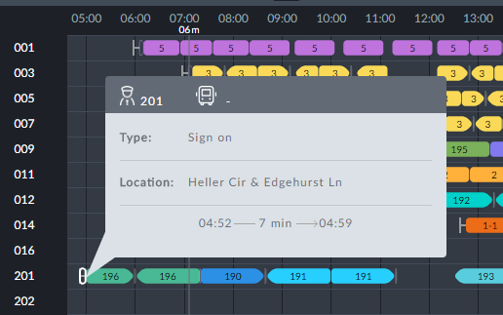

If you also have Vehicle Pre Trip set, you will see both of them:

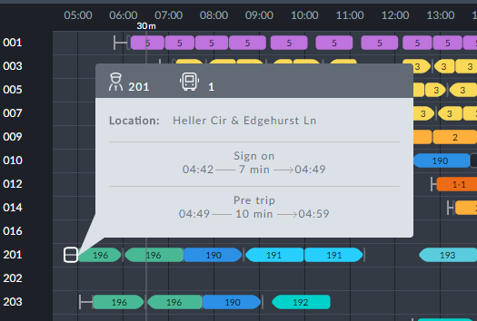

***Templates Available from Optibus***

*Table 1-1: Templates Summary*

|  |  |  |
| --- | --- | --- |
| **Template Name** | **Purpose** | **Reference** |
| Driver sign off - default | Sets the driver sign off time. | **Driver sign off - default** |
| Driver sign on - default | Sets the driver sigh on time. | **Driver sign on - default** |
| Sign on - Only from depot | Sets the driver sign off time where sign on must take place in a depot. | **Sign on - Only from depot** |

Sets the driver sign off time. **Prerequisites:** None. **Opening Dialog:**

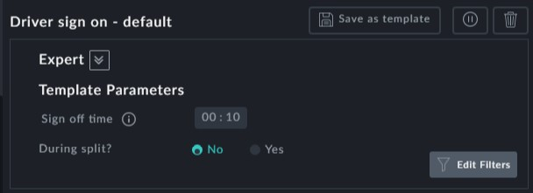

**Points to note:**

**During Split**: Set this to determine whether sign off time is allowed during a split break or not



You may create additional instances of this using Load Template



Sets the driver sign on time. **Prerequisites:** None. **Opening Dialog:**

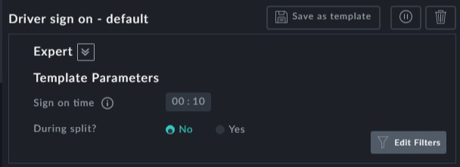

**Points to note:**

**During Split**: Set this to determine whether sign on time is allowed during a split break or not



You may create additional instances of this using Load Template



Sets the driver sign off time where sign on must take place in a depot.

**Prerequisites:** Vehicle depot circularity should be enabled in the **Depot Vehicle Alloc- ation** preference.

**Opening Dialog:**

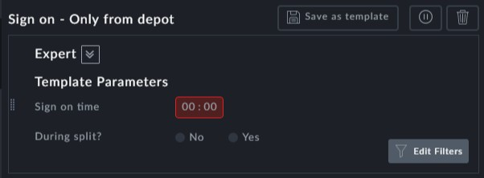

**Points to note:**

**Sign on time** is a mandatory field



**During Split**: Set this to determine whether sign on time is allowed during a split break or not



You may create additional instances of this using Load Template

